**CHAROTAR UNIVERSITY OF SCIENCE & TECHNOLOGY**

FACULTY OF TECHNOLOGY AND ENGINEERING

**Devang Patel Institute of Advance Technology & Research**

DEPARTMENT OF COMPUTER SCIENCE & ENGINEERING

**CSE246 Database Management System**

Semester: IV

Academic year: 2019-20

**PL/SQL Mini Project Report**

**AIM**

Create a mini project to handle the operations of Library Management System using SQL queries and PL/ SQL ( Use the concept of Cursor, Trigger, Procedure/ function, Package and Exception Handling )  
  
*Note: create at least three modules*

**EXPLANATION OF PROJECT**

This Project is a Library Management System. It consists of 4 Tables

* LIB
  + Book Name
  + Author
  + Publication
  + Number of Copies
* STUDENT
  + Roll Number
  + Name
  + Card Number
* BOOKS
  + Book Number
  + Book Name
  + Availability
  + Subscribed to
* SUBSCRIPTION
  + Book Number
  + Roll Number
  + Date of Subscription
  + Date of Return
  + Fine Amount
  + Status

This project helps Librarian to enter and maintain details about the books & students who issues those books.

**MODULES IN PROJECT**

1. Inserting Rows in table Student
2. Inserting Rows in table Lib
3. Procedure to take a Book
4. Procedure for Returning a Book

**PROGRAM CODE**

CREATING TABLE **LIBRARY**

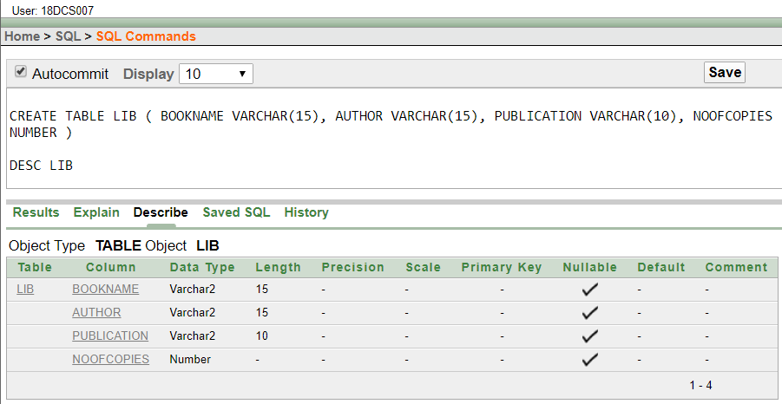

CREATING TABLE **STUDENT**

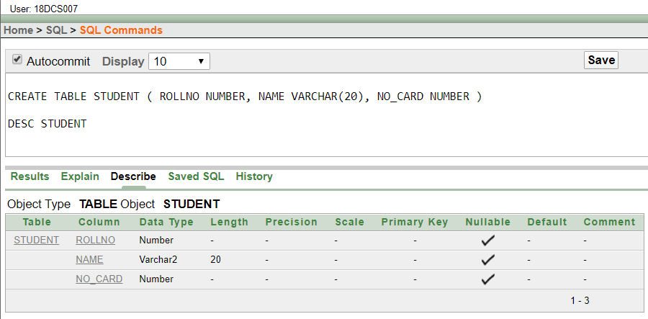

CREATING TABLE **BOOKS**

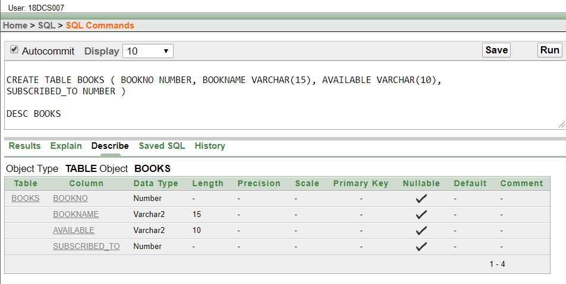

CREATING TABLE **SUBSCRIPTION**

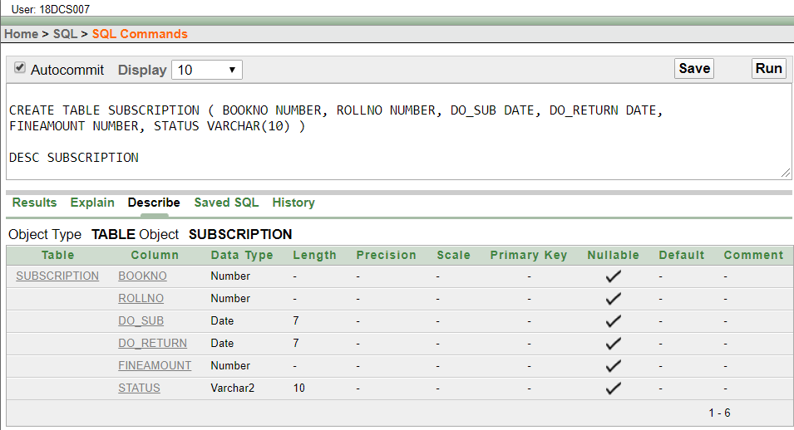

**INSERTING ROWS IN TABLE STUDENT**

declare

Roll number;

Name varchar(20);

Card number;

begin

Roll:= :EnterRollNumber;

Name:= :EnterYourName;

Card:= :EnterYourCardNo;

insert into student values(Roll,Name,Card);

end;

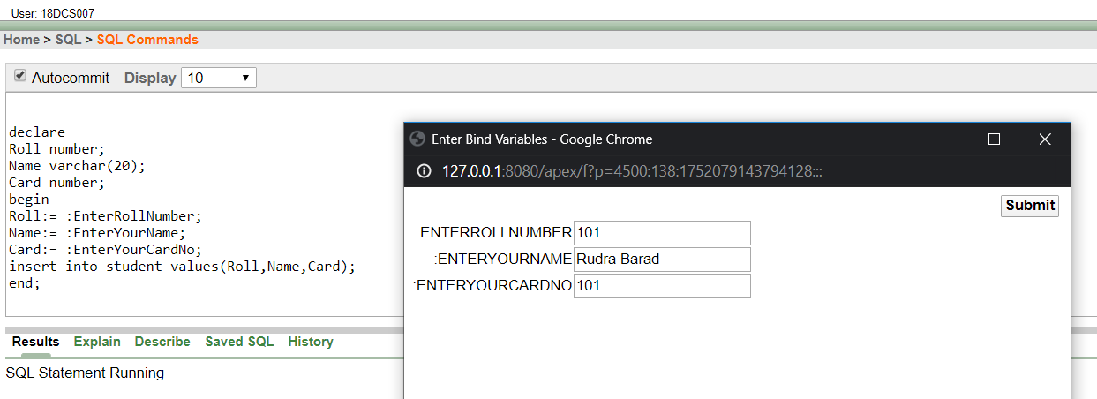

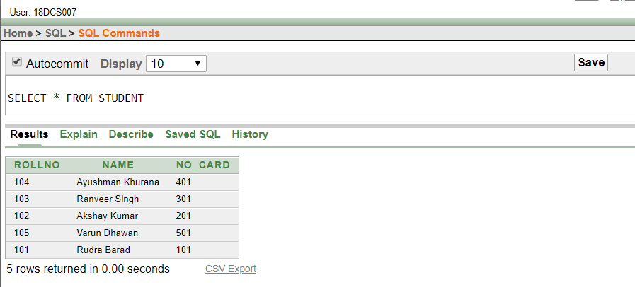

**INSERTING ROWS IN TABLE STUDENT**

declare

Book_no number;

Book_Name varchar(15);

Noc number;

Noc1 number;

Auth varchar(15);

Pub varchar(10);

Nobooks number;

lib_rec lib%rowtype;

begin

Book_no:= :Enter_Book_Number;

Book_Name:= :Enter_Name_of_the_Book;

Auth:= :Enter_Name_of_Auth;

Pub:= :Enter_Name_of_Pub;

Noc:= :Enter_Number_of_Copies;

Noc1:= Noc;

select count(*) into Nobooks from lib where Book_name=Book_Name;

if Nobooks=0 then

insert into lib values(Book_Name,Auth,Pub,Noc);

else

update lib set Num_of_copies=Num_of_copies+Noc where Book_name=Book_Name;

end if;

while Noc!=0

loop

insert into books values(Book_no,Book_Name,'yes',0);

Noc:=Noc-1;

Book_no:=Book_no+1;

end loop;

end;

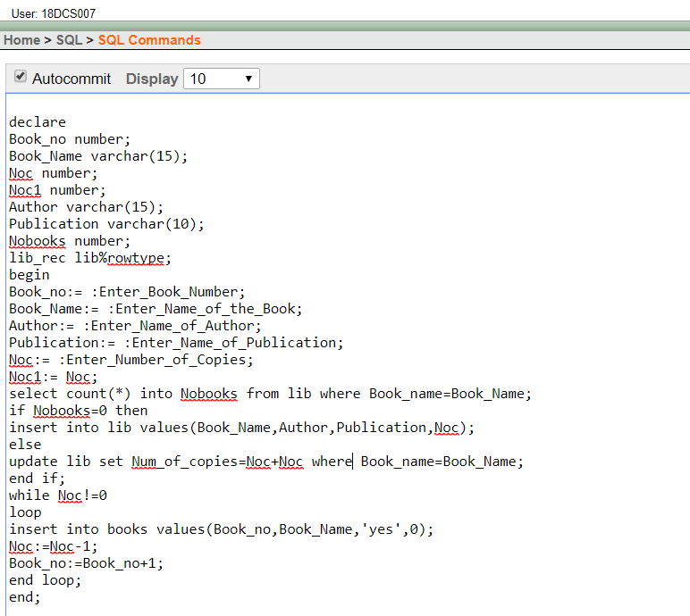

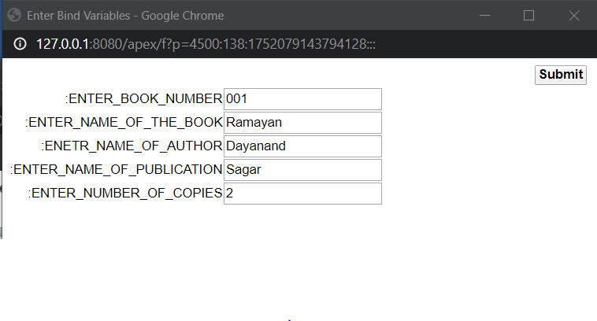

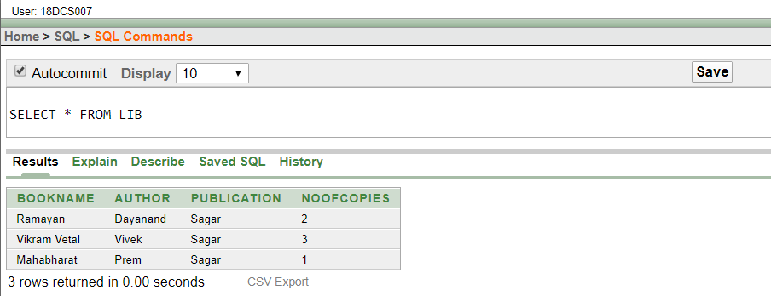

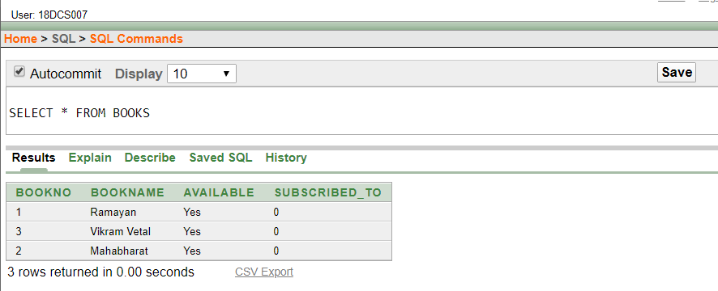



**PROCEDURE TO TAKE A BOOK**

create or replace procedure sub(bname char,roll_no number)as

lib_rec lib%rowtype;

book_rec books%rowtype;

stud_rec student%rowtype;

sub_rec subscription%rowtype;

book_no number;

no_of_books number;

begin

select * into stud_rec from student where rollno=roll_no;

if stud_rec.no_card=0 then

dbms_output.put_line('***************');

dbms_output.put_line('no card available');

dbms_output.put_line('***************');

else

select count(*) into no_of_books from books where bookname=bname and available='yes';

if no_of_books=0 then

dbms_output.put_line('***************');

dbms_output.put_line('book not available');

dbms_output.put_line('***************');

else

select min(bookno) into book_no from books where bookname=bname and available='yes';

insert into subscription values(book_no,roll_no,sysdate,sysdate+7,0,'ntreturned');

update student set no_card=no_card-1 where rollno=roll_no;

update books set available='no' where bookno=book_no;

update books set subscribed_to=roll_no where bookno=book_no;

end if;

exception

when no_data_found then

dbms_output.put_line('***************');

dbms_output.put_line('u are not a user');

dbms_output.put_line('***************');

end;

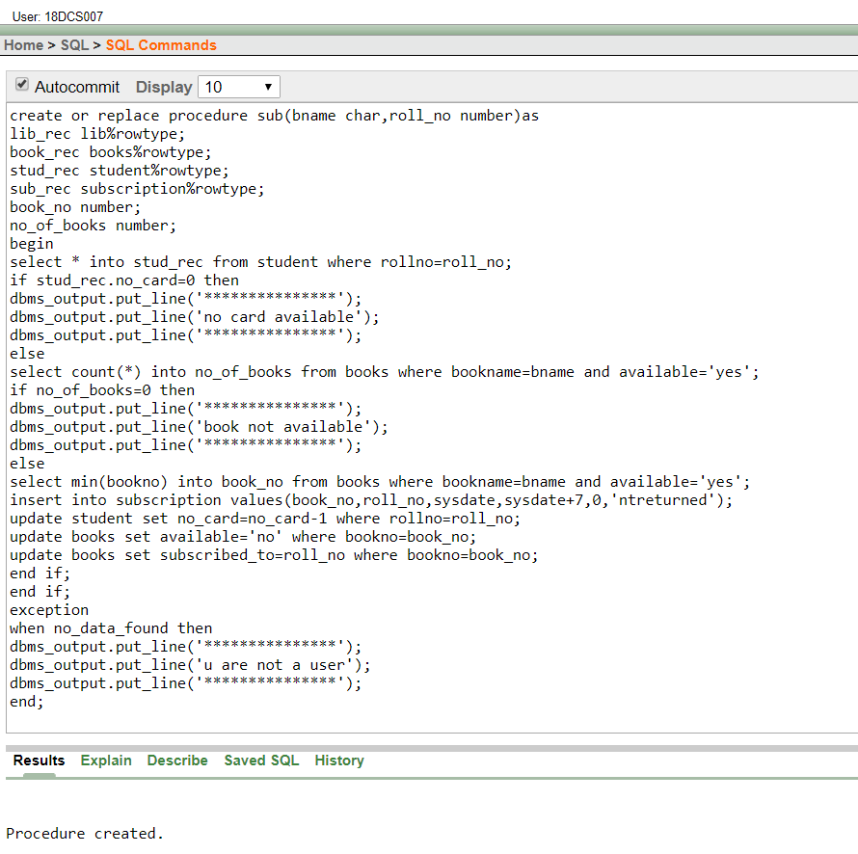

ISSUING THE BOOK

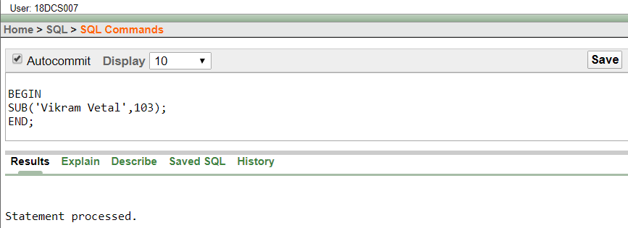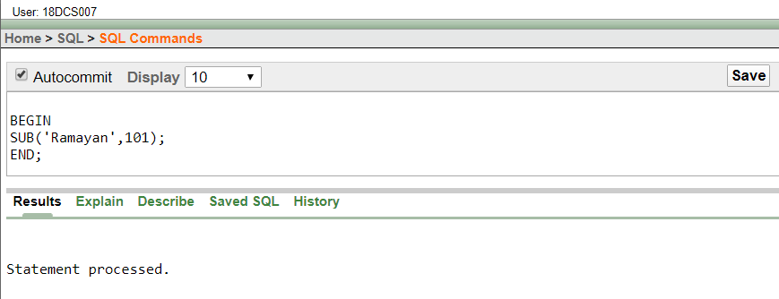

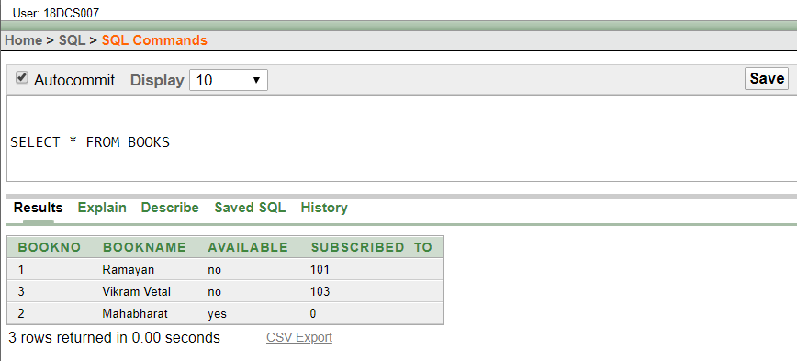

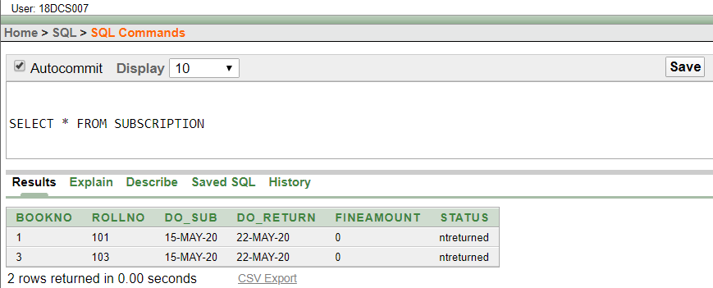

**PROCEDURE FOR RETURNING THE BOOK**

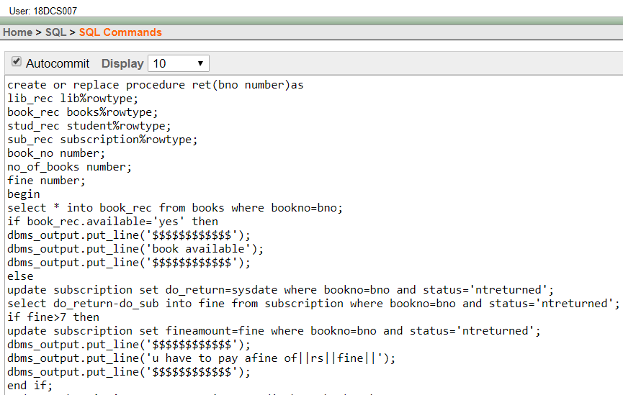

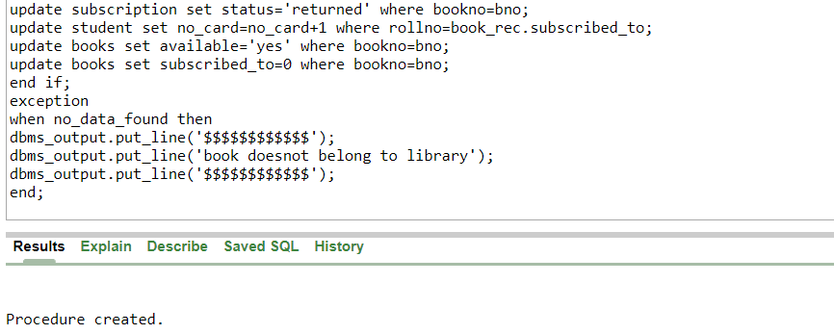

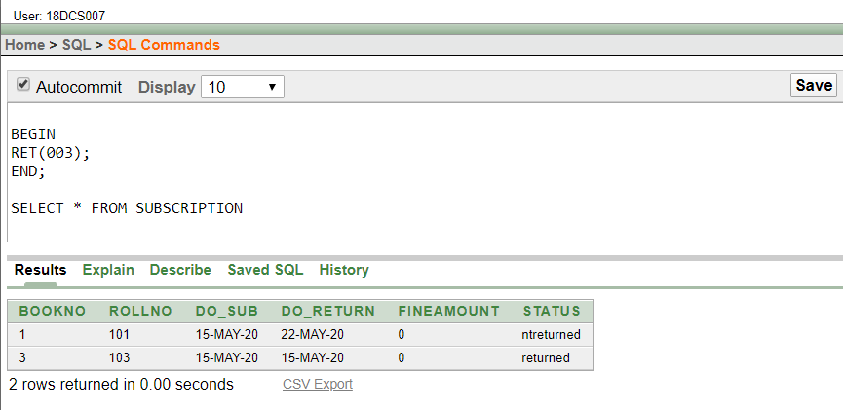

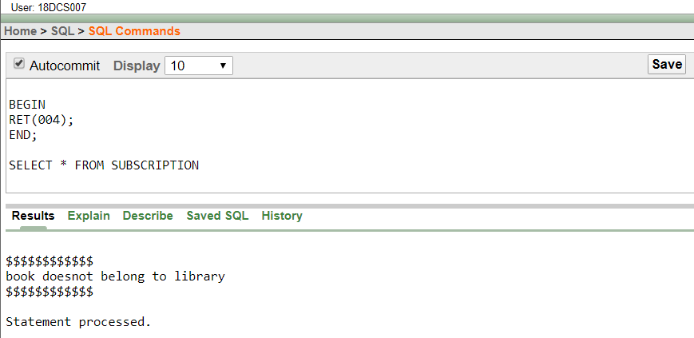

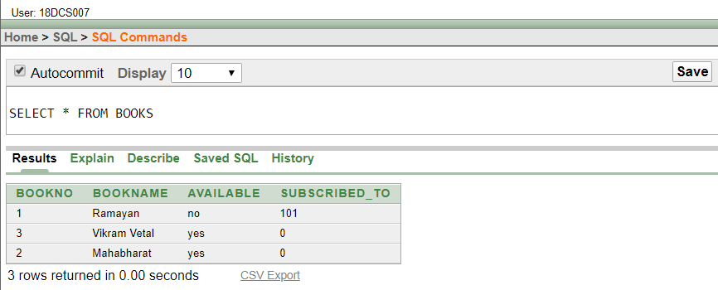

**CONCLUSION**

In this project, I have used the PL/SQL to create modules of Library Management. I’ve used different concepts like Packages, trigger and cursors.